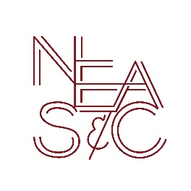

New England Association of Schools and Colleges, Inc.

Commission on Independent Schools

1115 Westford Street, Third Floor, Lowell, MA, 01851 USA

Release of Information

The Commission on Independent Schools, New England Association of Schools and Colleges, Inc. is hereby authorized to forward to the appropriate Diocesan School Office any and all reports and correspondence with the school related to the accreditation of:

Name of School:
Street Address:
City, State, Zip:
(Arch) Diocese:
This agreement will remain in effect until the Commission is notified in writing that the school wishes to cancel this authorization.

Signature – Pastor |  | Signature – Principal
Print Name |  | Print Name

- Please forward the signed form to:
NEASC Commission on Independent Schools
1115 Westford Street, Third Floor
Lowell, MA, 01851 USA
- Please send a copy to the Diocesan School Office.

Please check here if you do not wish to have the diocesan office receive accreditation information.

